**SAM DANIEL RAJ A – CSE FINAL YEAR**

**QUESTION**

Read about Apache Solr: [Solr Tutorial](https://solr.apache.org/guide/solr/latest/getting-started/solr-tutorial.html).

1. Install Solr on your local machine.
2. Create a collection in Solr.
3. Index the Employee data from <https://www.kaggle.com/datasets/williamlucas0/employee-sample-data>

STEP 1:

Apache solr installation: version 8.11.4

STEP 2:

Java installation lattest Version: JDK 23

STEP 3:

Start Solr: **bin/solr start**

STEP 4:

Open Solr in Browser

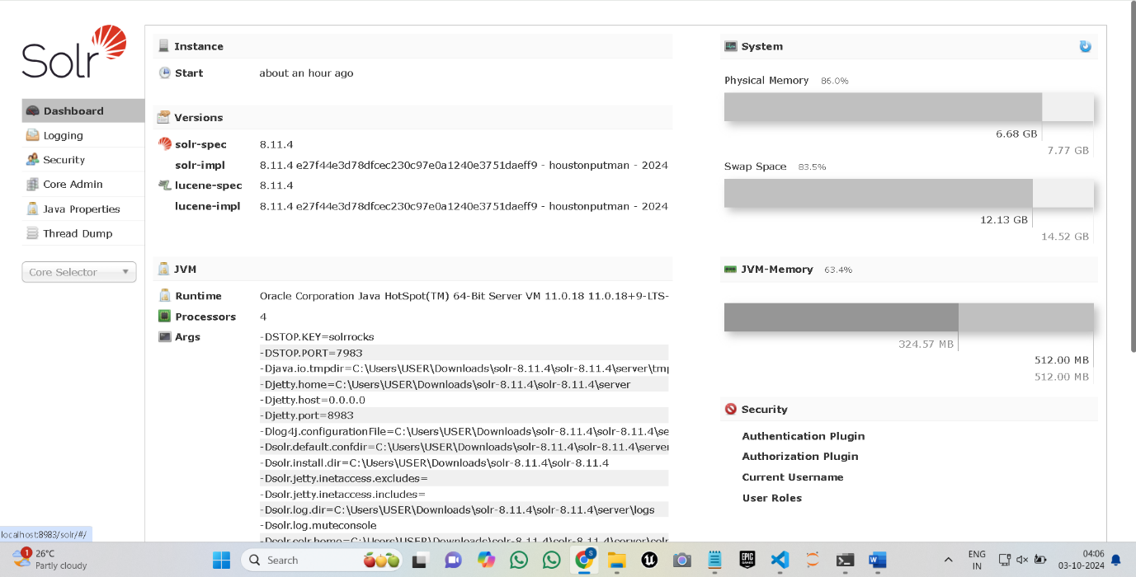

STEP 5:

Create a Core Admin

As Employee

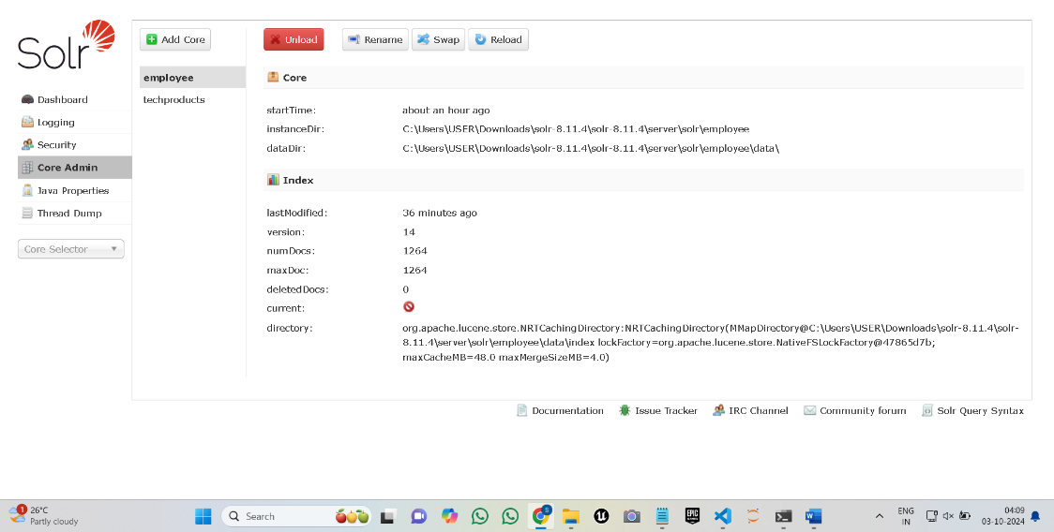

STEP 6:

Upload the Documents:

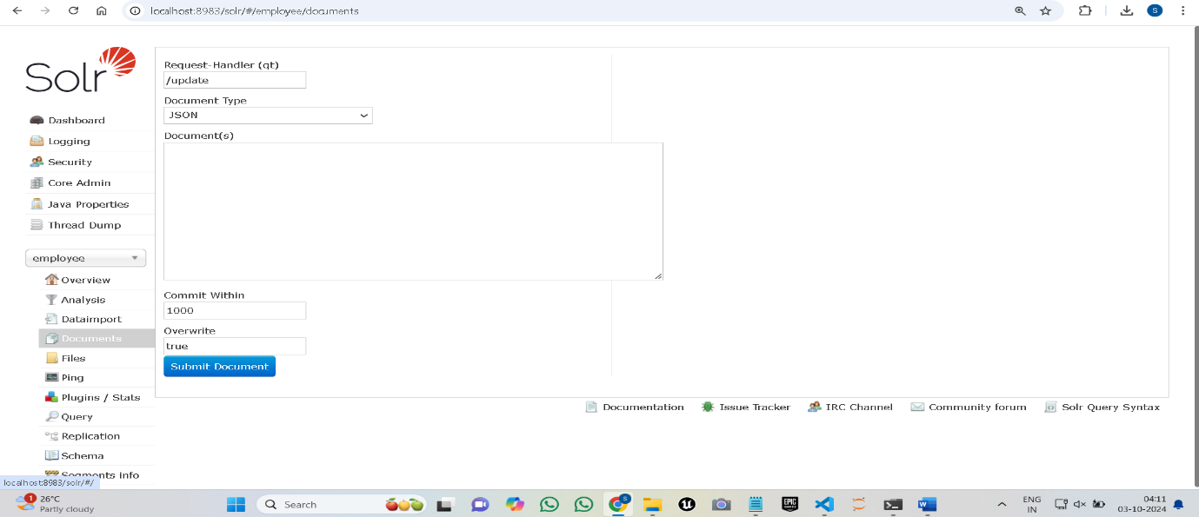

STEP 7:

You can ask query like:

http://localhost:8983/solr/employee/select?q=employee_name:John

It will work Return the Result